Lecture 01 - Course and Topic Area Overview
  - EE-30023/31023, Department of Electrical Engineering, University of Notre Dame

Summary
In this lecture, we will motivate the importance of electrical telecommunications in general, and the growing application in particular of wireless telecommunications via the radio frequency (RF) portion of the electromagnetic spectrum. We develop high-level summaries of number of realistic scenarios that arise in various applications of radio communications, and we describe the key system components and design problems that radio communication engineers need to solve. In particular, we stress the importance of digital communication technologies in all modern radio communication systems.

Outline
- Introductions
- Purpose and Scope of EE-30023 / EE-31023
- Contextual News Article: CBRS
- System Diagram, Radio Elements, & Interference Scenarios
- Regulation of the Radio Frequency (RF) Spectrum
- Spectrum Ecosystems
- Modern Radio Architecture
- Course Information Sheet & Survey

Purpose and Scope of EE-30023
The purpose and scope of EE-30023 are illustrated in Figure 1, which shows a block diagram for a communication system.
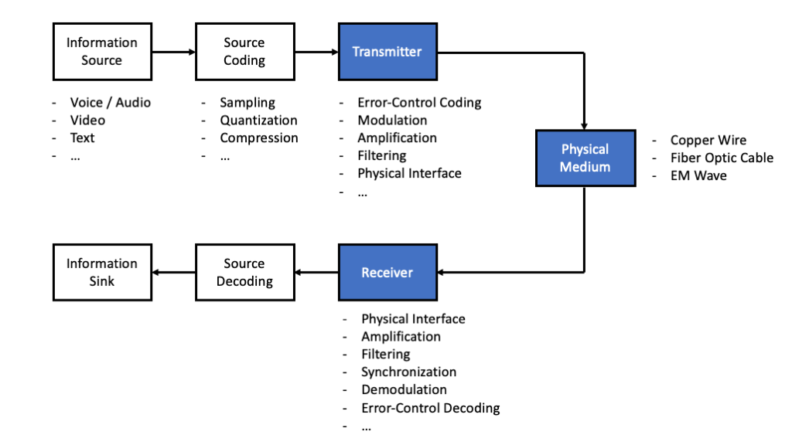
Figure 1: Block diagram for a communication system. The shaded blocks are topics of focus for this course.
Context
- Want to convey information from one point to another, possibly in a variety of formats
- Physical means of communication available to us, often relying on the laws of physics and involving noise and interference
- Communication system designers develop components to connect the information source, through the physical medium, to the information sink
- Digital communications involves systems in which at least some of the signals can be represented as bitstreams
The last point is more apparent from block diagrams of a digital transmitter and receiver in Figure 2 and Figure 3, respectively.
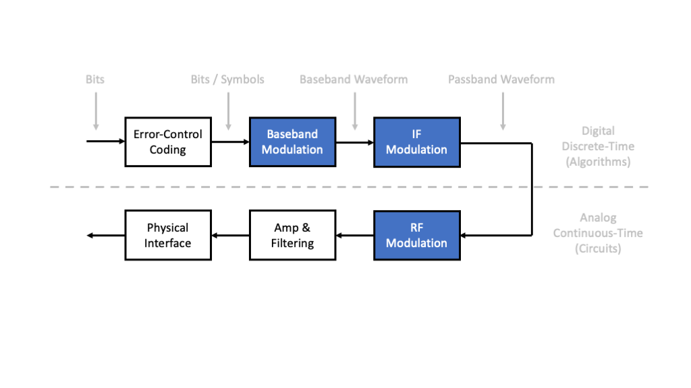
Figure 2: Block diagram for a digital transmitter in a communication system. The shaded blocks are topics of focus for this course.

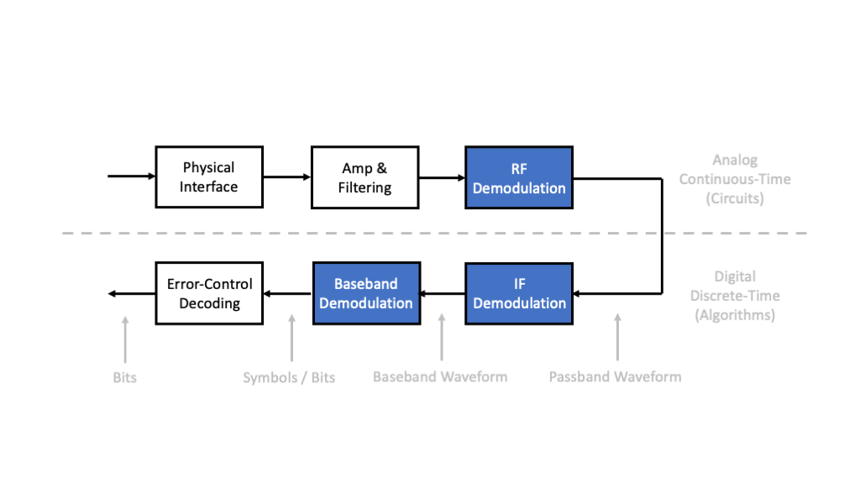
Figure 3: Block diagram for a digital receiver in a communication system. The shaded blocks are topics of focus for this course.
There are many motivations for digital communications, including:
- Fundamentally optimal, in the sense that Shannon’s information theory shows that separation of “source coding” and “channel coding” achieves the optimal performance theoretically attainable
- Divide and conquer, in the sense that separation allows one group fo engineers to worry about source coding into bits and another group of engineers to worry about channel coding and modulation of bits
- Circuit integration, since shrinking transistors allow increasingly complex algorithms for processing information and communication signals
- Robustness, in the sense that digital circuits have inherent margins that allow for designs to be produced consistently without requiring significant fine tuning
- Software, since digital processors (microprocessors, digital signal processors (DSPs), and field-programmable gate arrays (FPGAs) allow for algorithms to be reconfigured
Finally, although digital communications has significant industries around wireline (twisted pair, coaxial cable, fiber, power lines) and storage (magnetic disk and tape, optical disks, flash memory), we will focus on RF communication systems in which the physical interfaces are antennas. In this case, the transmitter converts information-bearing signals from currents and voltages into electromagnetic waves, and the receiver converts electromagnetic waves back into information-bearing signals. Such systems have become increasing important to modern society, as evidence by the evolving technologies such as 5G / 6G cellular, satellite constellations, significant military and public safety applications, and scientific uses such as environmental sensing and radio astronomy. Indeed, there are major industries organized around broadcasting, satellite and space communications, land mobile radio, cellular and mobile broadband, local area networks, and microwave backhaul. Often we need to design a communication system to coexist with these others user of the radio spectrum, which puts significant emphasize on interference concerns of neighboring radio systems. The next sections emphasize this point.

Contextual News Article
https://www.wsj.com/articles/wireless-companies-share-the-airwaves-11577538001
- Skim the article for a few minutes
- What buzzwords and acronyms jump out at you?
- What questions come to mind?
EXERCISE: Enter “radio+spectrum” into http://news.google.com/ and select 2-3 article for further reading.

System Diagram, Radio Elements, & Interference Scenarios
One or more radio frequency (RF) systems operating in nearby spectrum allocations can be illustrated via a system diagram.
In such a high-level diagram, we need to identfiy the following:
- radio elements: transmitters / emitters, receivers / sensors, networks
- operating parameters: locations, transmission ranges, directionality, frequency band and channel assignments, and signaling formats
- interference scenarios: situations in which one transmitted signal causes “harm” to a receiver of another signal because the elements / signals becomes “too close” in some combination of space, frequency, or time.

System Diagram Example: CBRS
The Citizens Broadband Radio Service (CBRS) band was allocated in the US to enable spectrum sharing between Navy radars and terrestrial cellular and other communication systems. Figure 4 below illustrates the relevant interference scenario.
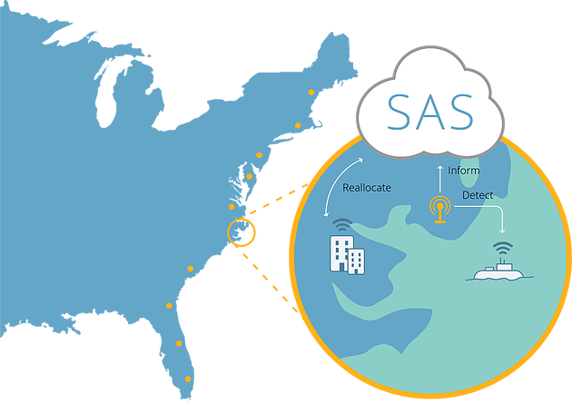
Figure 4: CBRS System Diagram from https://www.cbrsalliance.org/761-2/ .
In this system diagram, we have the follow radio elements: * Navy radar (emitter and sensor, typically) indicated by a submarine in the Atlantic * Cellular basestation and associated fixed or mobile devices (both transceivers) indicated by the building on the coast * Environmental Sensing Capability (ESC) devices (sensors) installed along the coast to detect the presence of the radar
There is also an important system component that is not a radio element. The Spectrum Access System (SAS) is a centralized database that collects information from the ESC devices, allocates spectrum to the cellular networks, and shifts them around in the spectrum to avoid causing interference to the radar
CBRS is being standardized to enable at least three tiers with different priorities for accessing to the band, as illustrated in Figure 5.
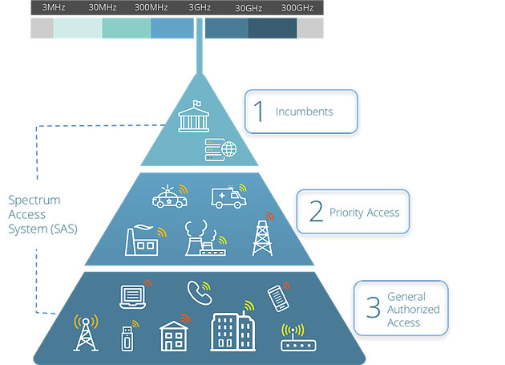
Figure 5: CBRS Tiers https://www.cbrsalliance.org/761-2/ .

Regulation of the RF Spectrum
Interference scenarios are managed through a combination of technology and regulatory policy.
Fortunately or unfortunately, technology alone has not been able to completely address interference problems. However, technology innovations enable new policy approaches, and vice versa.
In the US, the radio spectrum is legally regulated mainly by three organizations: * Federal Communications Commission (FCC) (https://www.fcc.gov), an independent agency with commissions appointmed by the President and approved by Congress, that regulates commercial and non-government use of the radio spectrum * National Telecommunications and Information Administration (NTIA) (https://www.ntia.doc.gov), an agency within the Department of Commerce that regulates government use of the radio spectrum * International Telecommunications Union (ITU) (https://www.itu.int/en/Pages/default.aspx), part of the United Nations that develops international treaties on spectrum use worldwide
Similar regulatory bodies exist in most countries around the world.
Figure 6 shows the current US spectrum allocation chart.
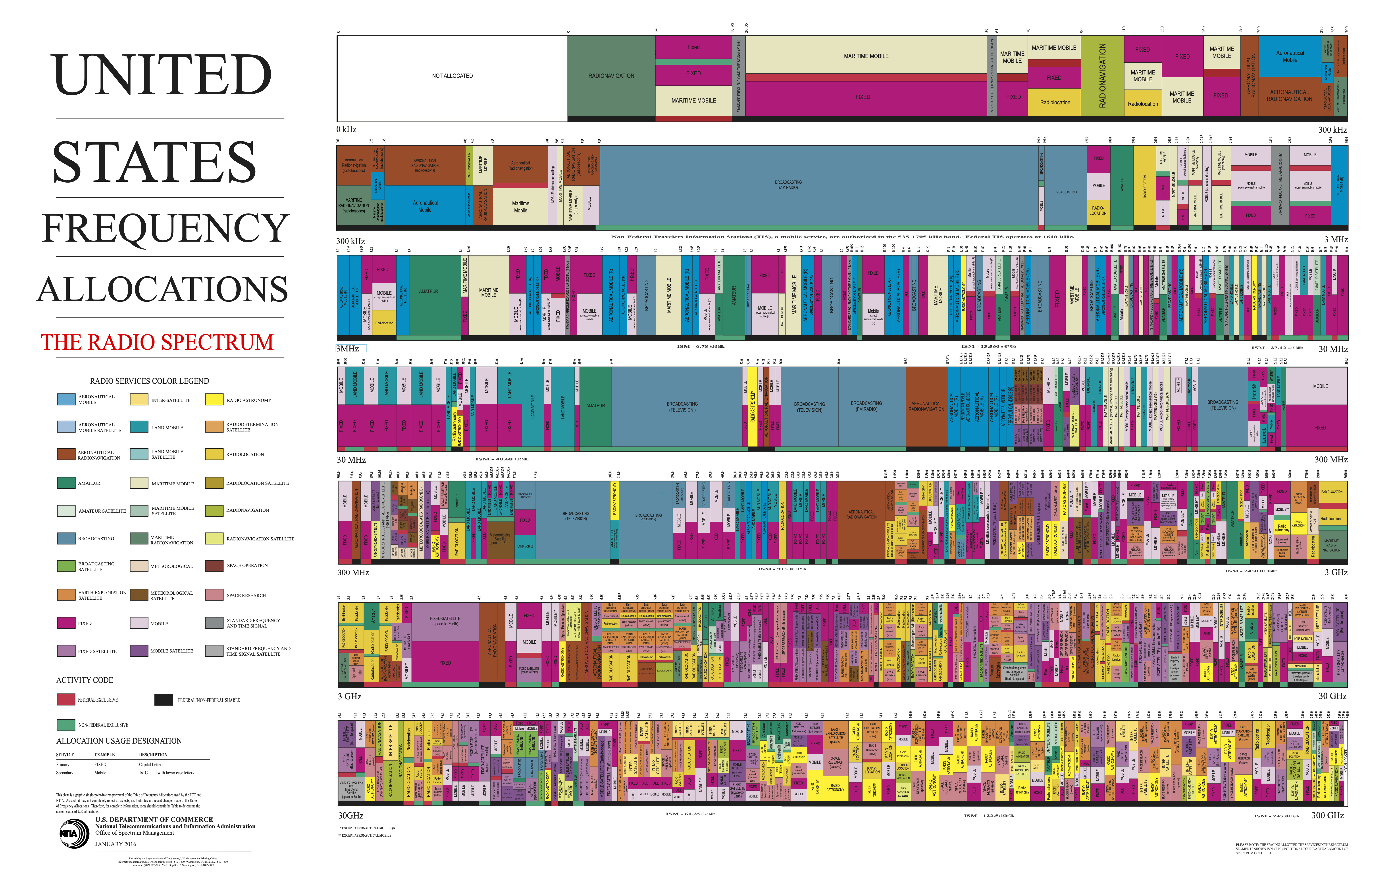
Figure 6: NTIA Spectrum Allocation Chart for the US from https://www.ntia.doc.gov/page/2011/united-states-frequency-allocation-chart .

Spectrum Ecosystems
We like to think of a spectrum ecosystem as a variety of wireless technology and related organizations that have the following in common:
- one or more frequency bands
- specific regulatory and economic frameworks
- underlying technologies and standards
Examples
- Radio Broadcasting (AM, FM)
- TV Broadcasting (NTSC, ATSC)
- Public Safety / Land-Mobile Radio
- Fixed Wireless (Backhaul, Access)
- Satellite Communications
- Cellular Communications (4G LTE, 5G NR)
- Wireless Local Area Networks (WiFi)
- Military Radar, Communications, Electronic Warfare
- …
EXERCISE: Pick 2-3 ecosystems and try to identify the common attributes and key players in each one.

Modern Radio Architecture
Despite the large number of spectrum allocations and ecosystems, modern radios have evolved to have very common architectures. A representative receiver architecture is illustrated in the figure below.
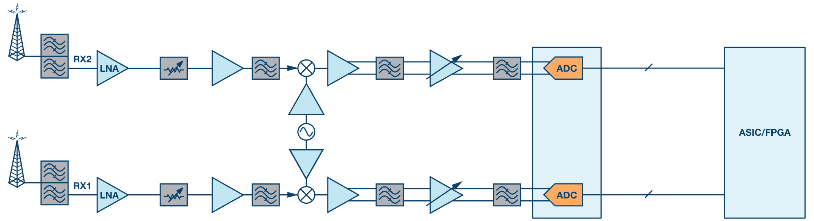
Figure 7: Modern digital radio architecture from https://www.analog.com/en/analog-dialogue/articles/a-selected-history-on-receiver-innovations-over-the-last-100-years.html .
This block diagram succinctly motivates varied components and topics required to design digital radio communication systems, including
- Antennas & Transmission Lines - Electromagnetics
- RF Down- and Up-conversion, Amplification, Filtering - RF Circuits
- Analog-to-Digital Conversion - Sampling and Interpolation
- Baseband Digital Computation Architectures - Signal Processing, Modulation, and Error-Control Coding Algorithms
- Networking - Network Architecture, Link and Network Protocols
Although complex and challenging, understanding of these concepts is applicable across all spectrum ecosystems!

Goals for the Course
- Foster awareness of wireless ecosystems that operate and collided in radio frequency spectrum
- Identify, model, and experiment with realistic interference scenarios
- Integrate prerequisite and advanced material to help students design, build, and test digital radio communication systems
- Enhance lab, programming, and technical communication skills
- Grow interest in the field and have fun learning!
NOTE: The remainder of the material was under development and not presented on 20200115.

Realistic Inteference Scenarios
- Cellular or WLAN: Two cellular or WiFi networks deployed in a given area, each with multiple basestations or access points, respectively. Can use frequency division multiplexing to separate networks from each other in frequency, but frequency reuse within each network requires user equipment or stations to constantly determine the strongest base station or access point, respectively, from their reference signal transmissions. These measurements are summarized to the network or optimization of associations. Once association is established, basestation or access point increasingly uses scheduling to prevent interference among user equipments or stations, respectively, associated with it.
- Satellite vs. Terrestrial: LightSquared vs. GPS, 5G vs. Weather Satellites.
- Electronic Warfare: Forces move into an area and need to scan the spectrum environment, either passively with sensors or actively with communicators and radars, to identify and track enemy systems. In some cases, intentional interference can be generated to deny enemy access to the spectrum while maintaining access for friendly systems.

Evolution of Electrical Telecommunications
One can argue that our modern “Information Age” has been fueled by the development of electrical telecommunications, which started during the Second Industrial Revolution or the Technological Revolution. To illustrate this point, a number of successfully commercialized technologies are summarized in the table below.
Invention | Inventor(s) | Date(s) | Modes | Information | Link
Telegraph | Samuel Morse | 1837 | Wired, Digital | Text characters | https://en.wikipedia.org/wiki/Samuel_Morse
Telephone | Alexander Graham Bell | 1875 | Wired, Analog | Speech | https://en.wikipedia.org/wiki/Alexander_Graham_Bell
Wireless Telegraph | Guglielmo Marconi | 1894 | Wireless, Digital | Text characters | https://en.wikipedia.org/wiki/Guglielmo_Marconi
Wireless Audio | Reginald Fessenden | 1906 | Wireless, Analog | Speech, Music | https://en.wikipedia.org/wiki/Reginald_Fessenden
Television | Philo Farnsworth | 1928 | Wireless, Analog | Video, Audio | https://en.wikipedia.org/wiki/Philo_Farnsworth
Internet | Lawrence Roberts, Donald Davies, Paul Baran, & Leonard Kleinrock | 1969 | Wired, Digital | Data packets with routing | https://en.wikipedia.org/wiki/Lawrence_Roberts_(scientist), https://en.wikipedia.org/wiki/Donald_Davies, https://en.wikipedia.org/wiki/Paul_Baran, https://en.wikipedia.org/wiki/Leonard_Kleinrock
Wireless LAN | Norman Abramson | 1971 | Wireless, Digital | Data packets without routing | https://en.wikipedia.org/wiki/Norman_Abramson
Ethernet | Robert Metcalfe, David Boggs | 1973 | Wired, Digital | Data packets without routing | https://en.wikipedia.org/wiki/Robert_Metcalfe, https://en.wikipedia.org/wiki/David_Boggs
Mobile Phone | Martin Cooper | 1973 | Wireless, Analog | Speech | https://en.wikipedia.org/wiki/Martin_Cooper_(inventor)
Electrical telecommunications involves two key aspects: 1) representation of information such as text writings, symbols, speech, images, video, and other intelligence in electrical form, and 2) transmission and reception of this information over long distances by electrical means.
Despite the oscillations over time, in any modern, large-scale network there are plenty of wired and wireless links, and in any modern, sophisticated radio there are plenty of analog and digital components.

Information and Communications Technology (ICT) Adoption Rates
The plot below shows the adoption over time of several information and communication technologies.
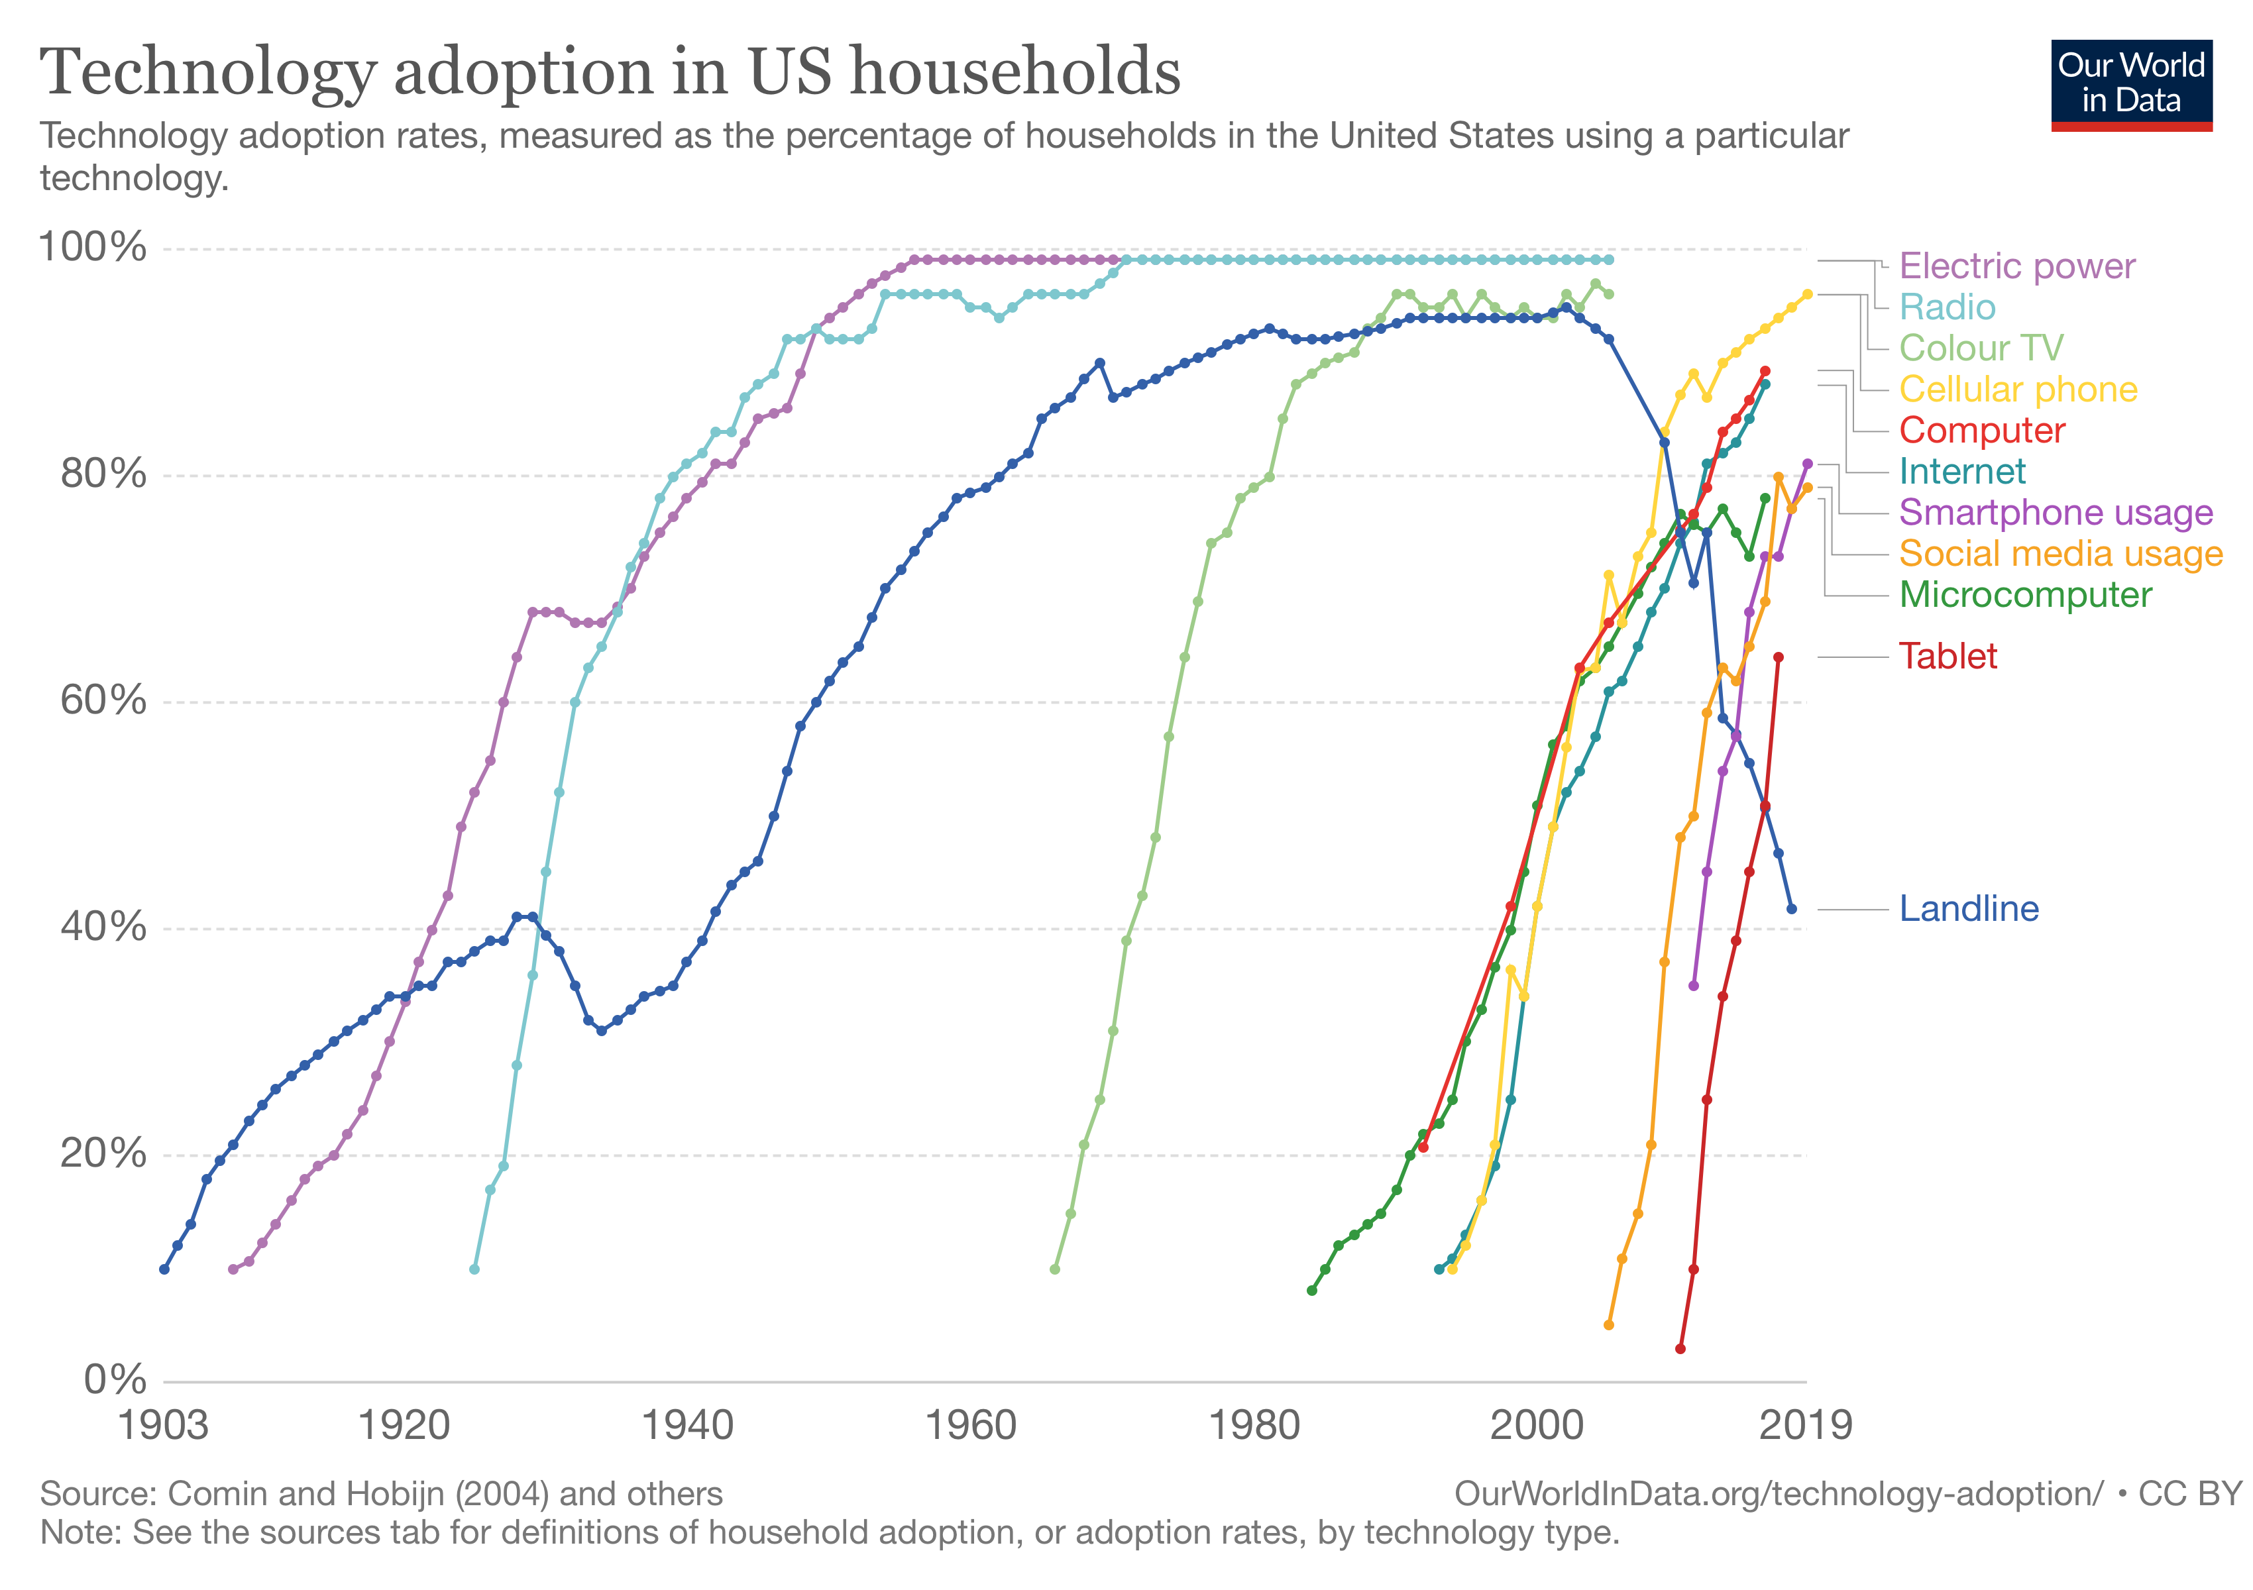
Figure 8: Technology adoption in the US over time from https://www.visualcapitalist.com/rising-speed-technological-adoption/ .
With a bit of squinting, one estimates that successful wireless technologies penetrate faster than wireless, e.g., comparing landline telephone to television and cellular phones.

International Telecommunications Union (ITU) Terminology
The ITU Radio Regulations provide legal definitions for 191 terms related to international spectrum regulations. Selected examples of such definitions are included in the table below.
Term | Definition
Telecommunication | Any transmission, emission or reception of signs, signals, writings, images and sounds or intelligence of any nature by wire, radio, optical, or other electromagnetic systems
Radio | A general term applied to the use of radio waves
Radio Waves (or Hertzian Waves) | Electromagentic waves of frequencies arbitrarily lower than 3,000 GHz, propagated in space without artificial guide
Radiocommmunication | Telecommunication by means of radio waves, including terrestrial radiocommunication and space radiocommunication
Radiodetermination | The determination of the position, velocity, and/or other characteristics of an object, or the obtaining of information relating to these parameters, by means of the propagation of radio waves, including radionavigation, radiolocation, and radio direction-finding
Allocation | Entry in the Table of Frequency Allocations of a given frequency band for the purpose of its use by one or more terrestrial or space radiocommunication services or the radio astronomy service under specified conditions. This term shall also be applied to the frequency band concerned
Allotment | Entry of a designated frequency channel in an agreed plan, adopted by a competent conference, for use by one or more administrations for a terrestrial or space radiocommunication service in one or more identified countries or geographical areas and under specified conditions
Assignment | Authorization given by an administration for a radio station to use a radio frequency or radio frequency channel under specified conditions
Radiocommunication Service | A service involving transmission, emission, and/or reception of radio waves for specific telecommunication purposes, including combinations of fixed or mobile stations as well as land, marine, aeronautical, or space stations
Radiodetermination Service | A radiocommunication service for the purpose of radiodetermination
Station | One or more transmitters or receivers or a combination of transmitters and receivers, including the accessory equipment, necessary at one location for carrying on a radiocommunication service, or the radioastronomy service, including terrestrial stations, earth stations, space stations, fixed stations, high-altitude platform stations, mobile stations, land station
Radiation | The outward flow of energy from any source in the form of radio waves
Emission | Radiation produced, or the production of radiation, by a radio transmitting station
Out-of-Band Emission | Emission on a frequency or frequencies immediately outside the necessary bandwidth which results from the modulation process, but excluding spurious emissions
Spurious Emissions | Emission on a frequency or frequencies which are outside the necessary bandwidth and the level of which may be reduced without affecting the corresponding transmission of information. Spurious emissions include harmonic emissions, parasitic emissions, intermodulation products and frequency conversion products, but exclude out-of-band emissions
Necessary Bandwith | For a given class of emission, the width of the frequency band which is just sufficient to ensure the transmission of information at the rate and with the quality required under specified conditions
Interference | The effect of unwanted energy due to one or a combination of emissions, radiations, or inductions upon reception in a radiocommunication system, manifested by any performance degradation, misinterpretation, or loss of information which could be extracted in the absence of such unwanted energy
Permissible Interference | Observed or predicted interference which complies with quantitative interference and sharing criteria contained in these Regulations or in ITU-R Recommendations or in special agreements as provided for in these Regulations
Harmful Interference | Interference which endangers the functioning of a radionavigation service or of other safety services or seriously degrades, obstructs, or repeatedly interrupts a radiocommunication service operating in accordance with Radio Regulations
Protection Ratio | The minimum value of the wanted-to-unwanted signal ratio, usually expressed in decibels, at the receiver input, determined under specified conditions such that a specified reception quality of the wanted signal is achieved at the receiver output
Coordination Area | When determining the need for coordination, the area surrounding an earth station sharing the same frequency band with terrestrial stations, or surrounding a transmitting earth station sharing the same bidirectionally allocated frequency band with receiving earth stations, beyond which the level of permissible interference will not be exceeded and coordination is therefore not required
Source: International Telecommunications Union (ITU), Radio Regulations, November 2016. https://www.itu.int/pub/R-REG-RR/en

