Welcome to RadioWare
  - EE-30023/31023, Department of Electrical Engineering, University of Notre Dame
EE-30023 and EE-31023 are the lecture and lab course numbers, respectively, for Digital Radio Communication Systems, a lab-based elective course offered to juniors and seniors in the Department of Electrical Engineering at the University of Notre Dame. The latest offering of this course is in Spring 2026.
  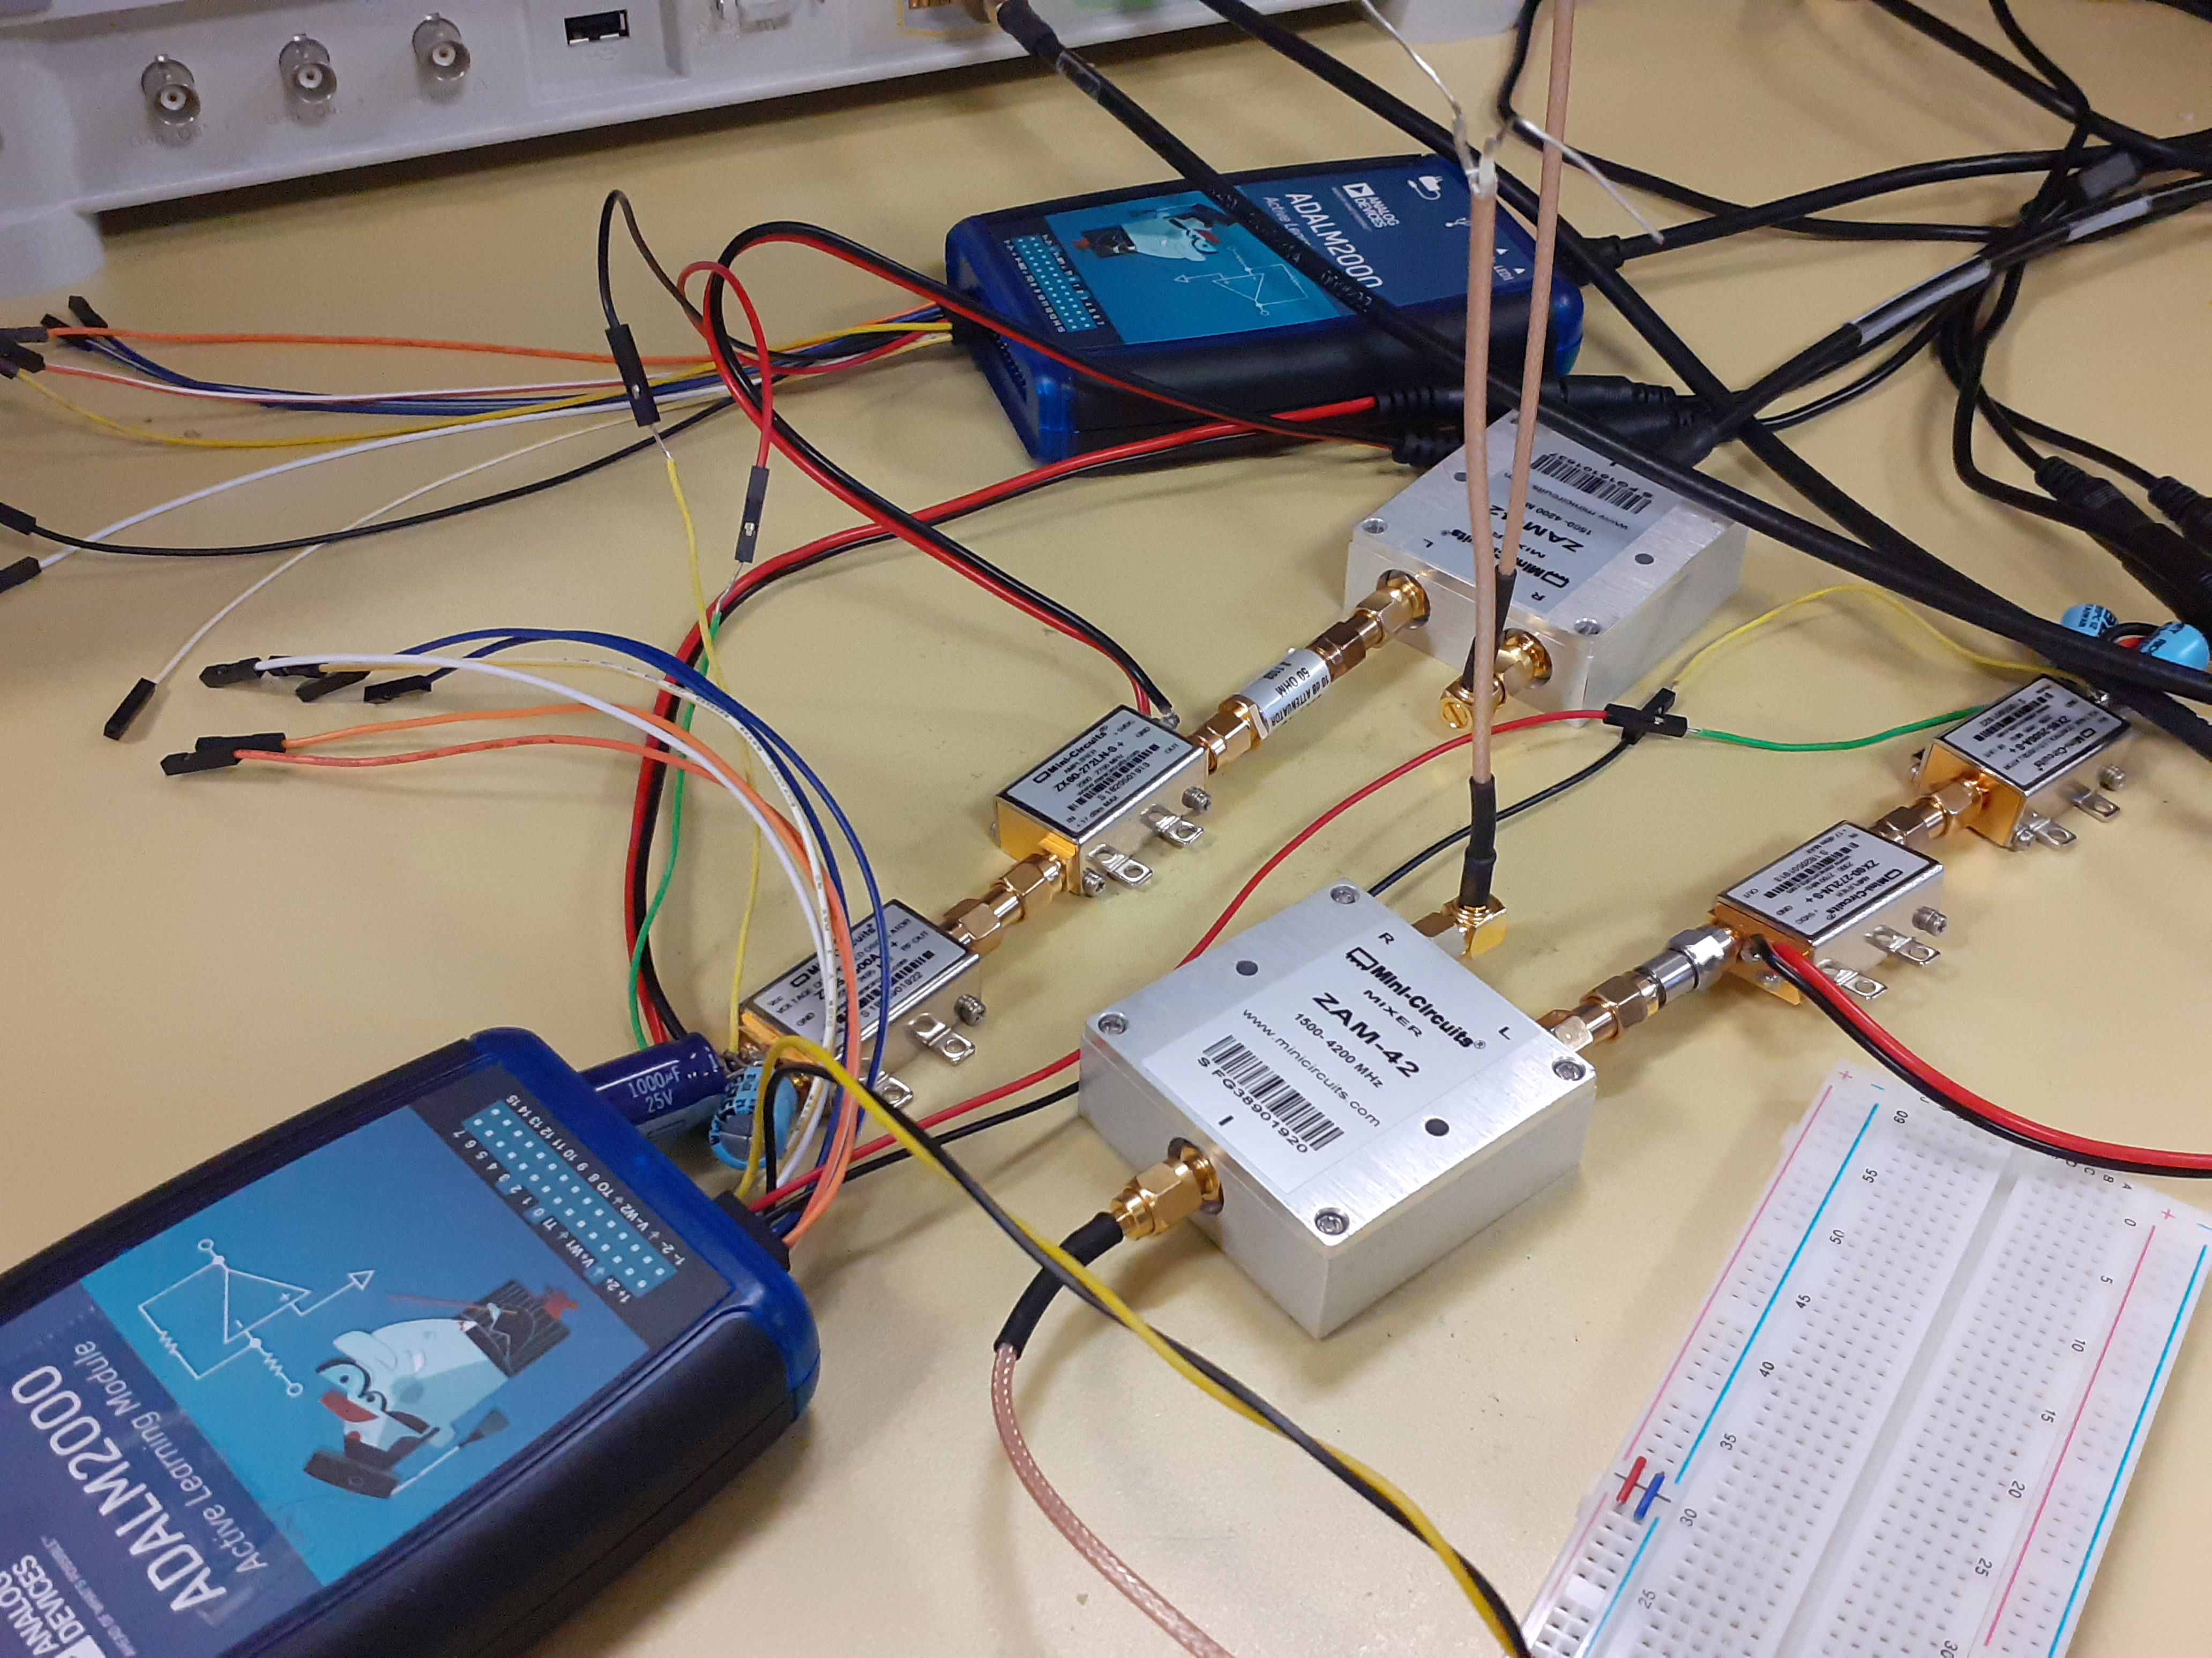
  RF Modules
  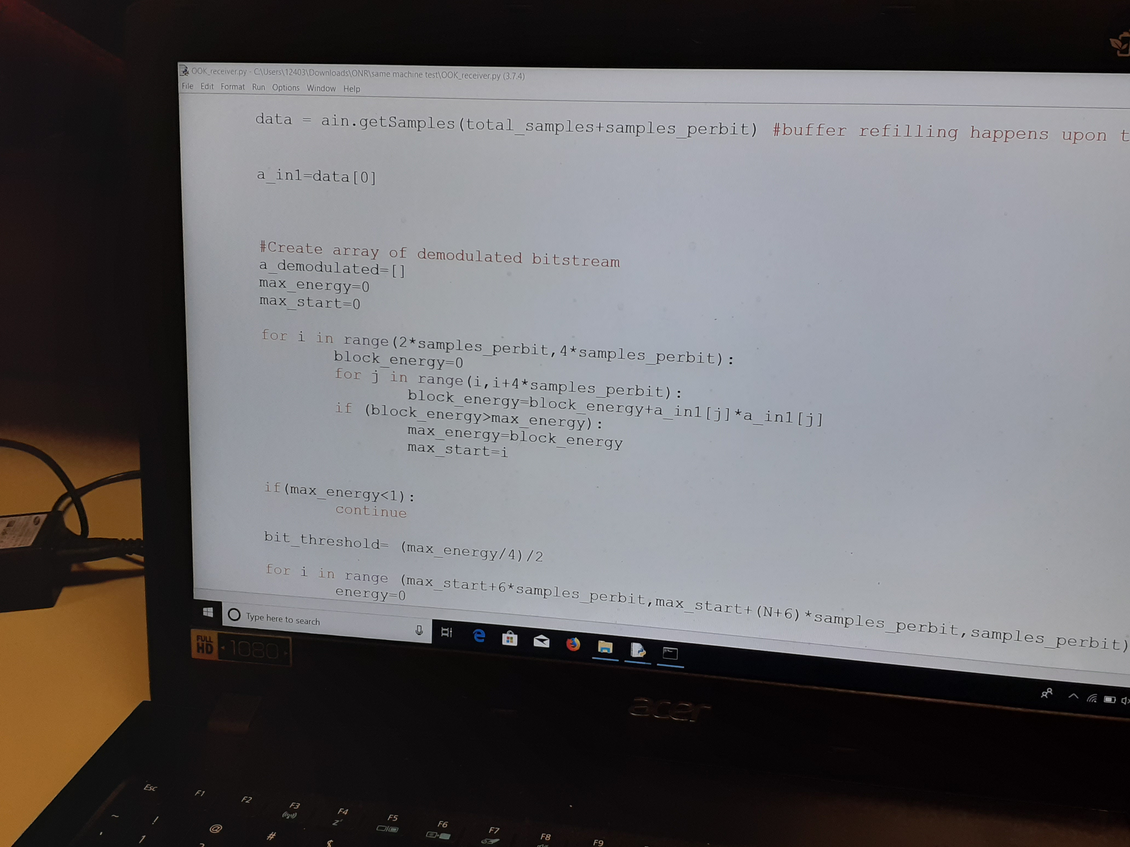
  Python Code

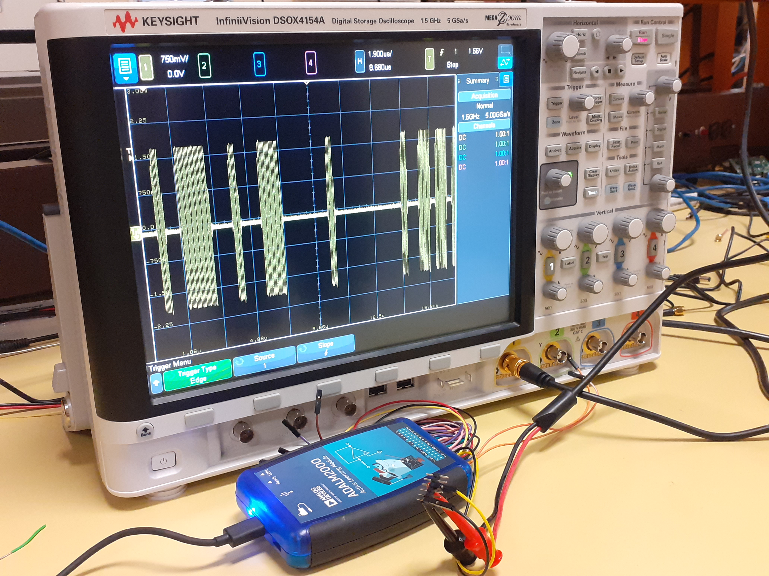
Measurement Equipment

High-Level Overview
Welcome! EE-30023/31023: Digital Radio Communication Systems is a junior/senior level elective course covering the basic concepts and practical aspects of modern, interference-limited, wireless communication and related systems.
Objectives for the course include:
- surveying characteristics and models of communication channels, transceiver architectures, and protocol stacks
- developing standard system block diagrams, component algorithms, and performance metrics
- fostering deeper exploration through hands-on-learning, collaboration, and self-study
Prerequisites for the course include EE-30122: System Theory and Application and co-requisites for the course include EE-30210: Random Phenomena in Electrical Engineering, their equivalents, or permission of the instructor.
This offering of the course is being significantly revised and evaluated with support from the Office of Naval Research (ONR) as well as the National Science Foundation (NSF), and leverages collaborative relationships with experts in the commercial industry as well as government agencies.

Motivation
Are you interested in learning the foundations of commercial wireless technologies such as 5G and Wi-Fi as well as military wireless technologies for communications, sensing, and electronic warfare? All of these technologies rely on digital radio communications, and they must operate in increasingly challenging radio frequency (RF) spectrum environments.
This course begins with an overview of realistic scenarios, in terms of applications as well as congested and contested RF spectrum environments, to motivate high-level design requirements for digital radio transmitters and receivers. Starting from a functional wired transmission system, students will cut the wire and add radio components and algorithms to successfully overcome wireless impairments such as propagation, noise, and interference.
More specifically, through a series of lectures and laboratory exercises, students will understand and model the key components of digital radios, characterize and optimize end-to-end performance, and build and test their own link-level digital radio transmission system through hands-on implementation. Student teams will also participate in red-teaming, an instructive feedback process in which they review, try to impair, and suggest improvements on each other’s designs.
In addition to enhancing conceptual understanding, the laboratory exercises will expand student skills in programming (Python, C), test and measurement, technical communications, and engineering teamwork. The lab kit, design and debugging skills, and conceptual understanding will provide students with a complete baseline for follow-on prototyping and research projects as well as deeper study in communication circuits, channel coding and modulation, and telecommunication networks.

Logistics
Lectures
- EE-30023 - Mondays & Thursdays, 11:00am-12:15pm
Labs (Choose One)
- EE-31023-01 - Mondays, 3:30-6:30pm
- EE-31023-02 - Tuesdays, 3:30-6:30pmpm
Instructors
- J. Nicholas Laneman, jnl@nd.edu (Lead)
- Bertrand Hochwald, bhochwald@nd.edu
- Jonathan Chisum, jchisum@nd.edu

Acknowledgements
This course was initially created and revised with support from the Office of Naval Research (ONR) Science, Technology, Engineering, and Mathematics (STEM) program through Grant N00014-18-1-2734. Current revisions are supported by SpectrumX, the NSF Spectrum Innovation Center, through NSF Award 2132700 operated under cooperative agreement by the University of Notre Dame.

